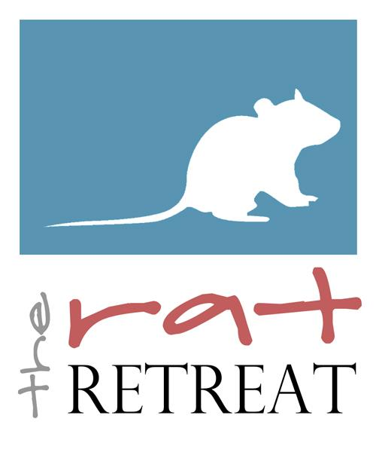
The Rat Retreat Adoption Application

About You:
Name(First/Last):

Address (Street/City/State/Zip):

Phone:

Email:

Do you (underline one): Own Rent Live with Parents

If you do not own your home, do you have permission to keep animals at this residence (underline answer)?
Yes / No

Do you smoke or does anyone in your household smoke (underline answer)?
Yes / No

Are there children in your household? If so, what are their ages?

If you answered yes to the previous question, please describe the child’s interaction with any animals in your home:

Are there animals other than rats in your home? If so, what other animals do you own?

If you answered yes to the previous question, please describe the other animals’ interaction with your rats:

Have you ever had to sell one of your pets, or surrender them to a shelter (underline answer)?
Yes / No
If yes, please explain:

About Your Rats & Their Care:
How many rats do you currently own (please list ages & genders)?

How long have you kept pet rats?

Please describe the cage(s) that you use for your rats:

What kind of bedding do you use?

Please tell me about your rats’ diet:

How much time does each rat get out of the cage per day?

Are you familiar with common rat health problems?

Do you currently have a veterinarian who has experience with rats (please list name of vet and address)?

Do you seek veterinary care for your rats when necessary?

About Your New Rats:
How many rats do you plan to adopt?
(If you do not already have rats at home, you must adopt in same-sex pairs.)

Do you have a transport carrier?

Will you quarantine your new rats?

If yes, please describe your quarantine set-up (location, cage, etc):

Do you plan on breeding your rat(s)?
*Note: All of our rats will be adopted under a pet-only contract*

What method of introduction do you use?

Miscellaneous
How did you discover us?

What made you decide to adopt from us?
Do you have any preferences you are looking for in a rat, regarding gender, color, ear type, and
coat type (if yes, please specify):

Photo
In addition to this application please email a photo of your current cage setup to leisha.ratretreat@gmail.com.

I certify that I have answered all questions truthfully.

Signature: ____________________________________________

Parent/Guardian Signature:_______________________________
(If under 18)

Email completed application to leisha.ratretreat@gmail.com

THANK YOU!

